

|  |
| --- |
| *BS Cyber Security Department AU* |

|  |  |
| --- | --- |
| **Registration ID** | **233026** |
| **Submitted By** | **Muhammad Sohaib Rafiq** |
| **Submitted To** | **Iram Fatima Hashmi** |
| **Date of Submission** | **05/20/2025** |
| **Assign NO.** | **2** |
| **Subject** | **OS LAB** |

**Setting up the environment:**

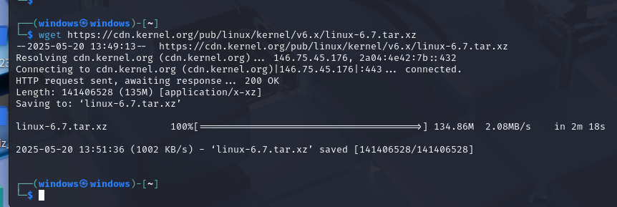

**Kernel configuration:**

**Here at the first time I faced the error because the bison tool is not installed that the make**

**Localmodconfig**

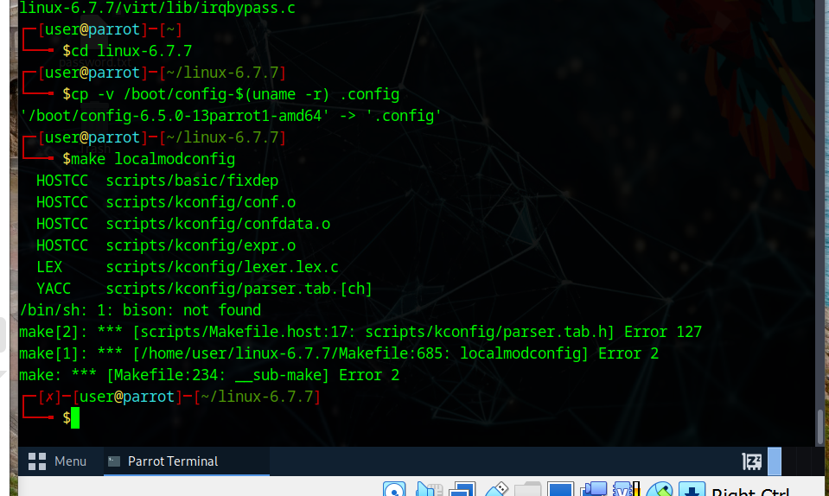

**After fixing the bison error now the make localmodconfig runs successfully.**

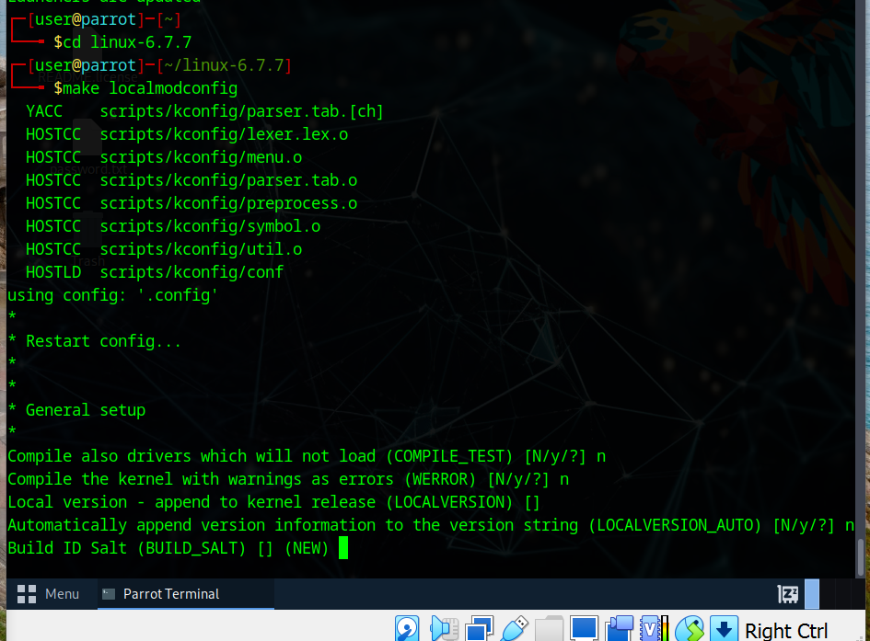

**make -j$(nproc)**

**make modules -j$(nproc)**

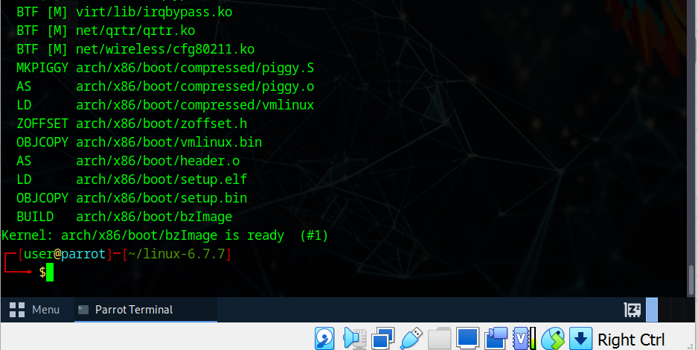

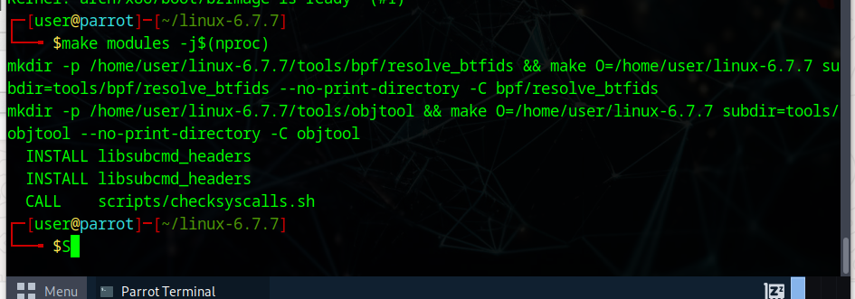

Step 7: Install Modules

The commad is sudo make modules-install:

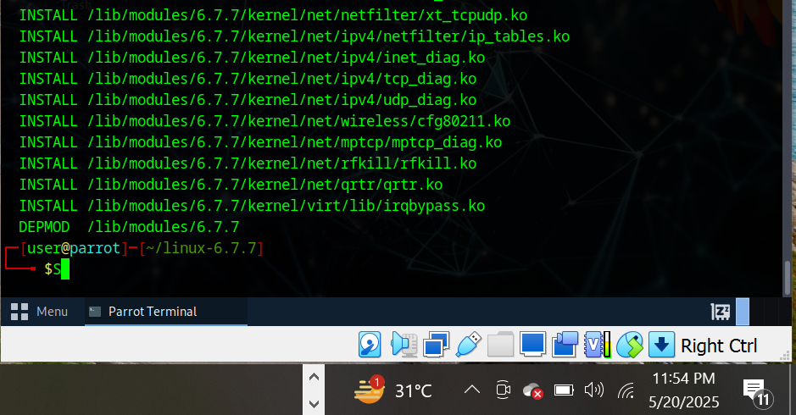

Step 8: Install the Kernel:

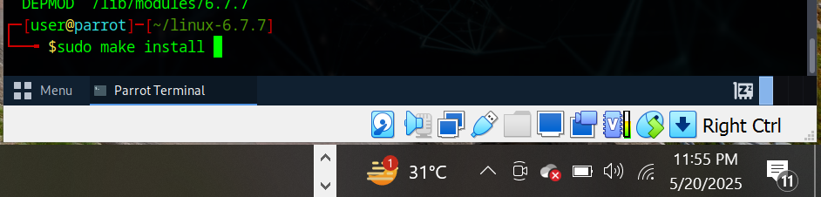

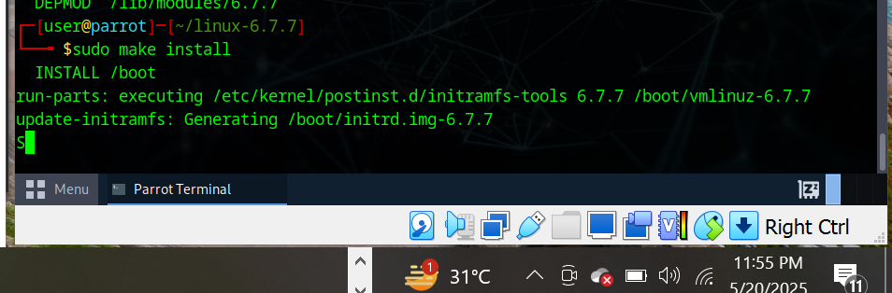

Step 9: Update Bootloader (GRUB)

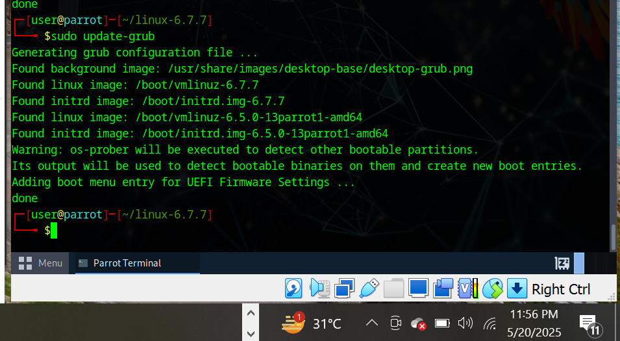

Step 10: Reboot and Verify

Sudo reboot

Verify the kernel

